Womanhood of Acceptance
I know I arrived in Boston on November 25th, 1983. It was a long trip. I left by car from El Salvador to Guatemala. Then from Guatemala to Mexico, where I crossed the river—the Rio Grande, also known as, el río Bravo, into Texas. So, I entered illegally into the United States. From Texas, I took an airplane to Boston. I was 19 at the time—I’m 53 now.
The most intense portion of the war had passed in 1980. I lived through the civil war that devastated El Salvador. My husband interjects— “it hadn’t passed, that was during the war”. I readjust, “right, so I guess around the 80’s it had really only begun, huh. So, I pretty much lived in El Salvador during the war”.
I knew I was leaving which meant I had to obtain all kinds of documentation. My younger brothers were under 18 so they required permissions in order to leave the country. Prior to beginning the trek, we obtained a Mexican visa to enter Mexico. My mother had arranged, from the U.S., for a coyote to lead us to Mexico. Later, that coyote had his own connections to guide us across the river. I remember it was so cold; it was the middle November. We were told to take our clothes off and carry it over our heads while swimming across the river. As soon as we got across we had to put our clothes back on—freezing and wet. On the other side of the river, it was nothing but uphill shrubbery. We had to crawl like soldiers at war all in between the shrubs. They would tell us to get down, “aí viene imigración”, they would yell. Once we arrived at a paved street I was accompanied by my uncle’s wife and my 9-year-old brother. In that moment, I realized that we were in America.
We met up with the coyote who had brought us from El Salvador at an 18-wheeler along this dark, empty highway. The driver was a Mexican who was married to an Anglo-American woman and they had a child together, I remember them. That night, we slept in the bed of the truck and above all I remember quavering from the cold. It was awful. But even then, I don’t think I suffered as much as others. I say that because I’ve heard worse stories of those who have crossed by desert, train, or endless walking. The most horrifying stories are those of women who have been violated, raped, and murdered along the way. And of course, there’s the stories of all those who don’t make it. In Texas, we stayed with the truck driver and his family for a couple of days. It’s so memorable for me because the trailer we stayed in was so messy—you know me, I immediately thought, “¿¡como pueden vivir así!?”. Our first day we ate tacos and tortas, you know, it’s Texas. My mom had sent money for us to get winter clothes. Could you imagine, us, trying to find winter clothes in Texas! My younger brother who was 15 at the time, joined us a month later in Boston on December 24th.
I left my father behind. I left my country behind, culture, friends, myself—everything. Today I don’t feel like I’m from here nor there especially since I’ve lived here longer her than I lived in El Salvador. Along with that, I don’t even speak English or Spanish, really. It’s bien triste to think about that too much. So, I frame it like this: had I stayed there I wouldn’t be who/how I am today. Who knows if I would have been better off staying or leaving? I think about it but then I remember, el país pobre—there’s no work. Seeing how people live over there it is easier for me to believe that I am better off here. Here, there’s work. I know I’m going to get a paycheck every week. But here, you don’t enjoy life. When I see people in El Salvador, they are happy and they don’t have anything. It’s funny, all the worry is usually about is what they want to eat after breakfast. But they remain as the hardest working people I have ever known.
Coming here wasn’t my choice; my mom was here. My mom made a decision because she wanted to leave my father. Immigration was the only option she had. In El Salvador, and I remember this even as a kid, they would talk about the United States like el gran país, país de los sueños. So, I grew up thinking, one day I will go to the United States; one day I will get on an airplane (self-fulfilling prophecy, I guess). So when I was told that I was going on this journey to America, I saw it as a chance to live the dream I’ve had since I was a kid. But again, I had no choice. I saw this as an opportunity to reach the country of dreams. The dream is such that my dad let us leave knowing that he might never see us again. I wonder what that was like for him but I know it’s an opportunity one cannot pass up. He signed all the necessary permissions for my younger brothers to leave the country.
Nonetheless, I was so happy to see my mom; I hadn’t seen her for years. She immigrated in 1981, without us. When we arrived, she had acquired a four-bedroom apartment for us; it was nice having our own bedrooms.
I remember working as a secretary in El Salvador and one day my boss told me, “no te vayas”. What are you going to go do in America? That place is not what people think it is”. In the moment, I didn’t know what he was talking about. I didn’t pay it any attention. Now I understand what he meant to tell me. This place is known for the “American Dream” but I never lived that. When I arrived in the U.S. I had to work as a housekeeper. This was something I had never done before. In El Salvador, I went to school, I studied, I learned how to type; I had a good job as a receptionist. On top of that, we had our own maids in our household. That’s just how it is over there. We were poor but we still paid people to do the house chores. Everyone has a maid. So, you can imagine the kind of shock that took over when I was the one cleaning. All I thought was, “Dios mío…. ¿por qué?”. It was in that moment I realized what my boss had meant.
The language was so difficult. I didn’t speak English. But the cold was all the more unbearable; we arrived in November just in time for a brutal New England winter. My mom didn’t have a car and none of us spoke English. I remember having to deal with the smallest inconveniences. Neither my mom nor I knew how to write our address. In El Salvador the address is written in reverse; we would write the name of the street then the house number and it would confuse people (along with the language barrier, we were always lost). It wasn’t until our mailman in Chelsea taught us how to write it properly. Buses here are also culturally different. In El Salvador—laughs—the buses are always full. There’s people hanging from all parts of the bus, all packed in there. Here, you would throw in your token and be able to take a seat but you had to try not to die from overheating (from the intensity of the heat on the bus and the endless layers of winter gear). I remember the constant in-and-out of hot heat and cruel cold winds. I recall going to Market Basket with my mom in Chelsea—we would take the bus to the grocery store and come back by Taxi with the groceries (dealing with all these previously mentioned issues). I remember always longing for my Salvadoran food and fruit. In El Salvador all trees give some kind of fruit. In Boston, there weren’t many tiendas hispanas that we knew of, or they tended to be small stores that only carried Puerto Rican foods (it was practically impossible to find Salvadoran foods). There were no avocados, mangoes, masarina (corn-based flour)—so no tortillas (it was like it didn’t exist). These days you can find almost anything at Market Basket and Stop-n-Shop. It was difficult being undocumented.
One comes to this country, without knowing English and one realizes how frustrating communication can be. So, I enrolled at Bunker Hill Community College to learn English. I wanted to get a degree but this was impossible as an undocumented person—especially financially. I had to pay out of pocket for one semester of English classes. I only participated in one semester because I had to take care of my brothers while my mother worked overnight shifts. After my first semester, I had to go back to work. I worked with my mom for some time in a lamp factory. Let me tell you, this experience was dreadful. It was an especially long journey to get to the factory (located in Medford, MA). We would pack our breakfast and lunch and begin our trek to work by walking, taking a long bus ride, then walking more. On top of this, the job was physically demanding and exhausting. We worked in teams on different conveyor belts that didn’t stop. If we needed to use the restroom, we would have to ask our boss to take over for us until we returned. I remember being so embarrassed by this because I was pregnant at the time and constantly needed bathroom breaks. I would come home with strained hand muscles from tying lamp wires together all day. I knew I couldn’t do it for long; I realized that I couldn’t live like that. When I was pregnant with my second son, I was working as a housekeeper. During this time, I participated in a program in Chelsea to help me obtain a G.E.D. while also taking classes in Somerville to learn English. I had to learn to manage my time between having a toddler, work laboriously, and learning. Nonetheless, I was also able to obtain a certification for computer competency. The school in Chelsea was contacted by a non-profit known as the, Metropolitan Boston Housing Partnership, who sought a bilingual receptionist. I was the best student in our class and was offered an interview. I specifically remember feeling that my life had changed when I accepted the position. I went on to work there for 17 years while also helping others in my family obtain jobs with this company (we still have family members who work there today).
I always ask myself, when I’m being reflective, about how I was treated when I first came here especially when I hear horror stories of how others have been treated. I know discrimination is something that one feels. So fortunately, I can say that I can’t recall a memory of feeling discriminated against. I have always worked in settings that have been ethnically diverse (most of my jobs have been in the industry of housing). I have worked with and for people across the racial/ethnic spectrum. Being a bilingual person has helped me tremendously to work in these kinds of settings where I was treated well because I had a skill that my employers needed.
I look back now, to almost 34 years ago, I can’t say if discrimination was or was not as extreme as it is today. I can’t comment on whether it was harder then or harder now. I don’t know. Cada quien con su propia experiencia.
As I got older, my perception on America changed. I realized that here, as long as you work, you can achieve anything you want. Here, I can have the car of the year, a house, anything I want as long as I work to get it. And I know this is possible because that’s what my mom did. She worked three jobs and she got us here. If that’s not the American Dream, I don’t know what is. When I came here my hope was to return to El Salvador after three years. At the beginning not knowing where I was coming or what my life would turn out to be, I always claimed that I would go back. Now as a vieja, I’m thinking about going back for good—unless I get some grandchildren.
My first friend here, was the person who is now my husband. He got close to me and always reassured me that if I ever needed someone who spoke English, he was there—laughs. I went to high school in Boston for some time with my brother when I first arrived. I learned that the school systems here are different; we were in this massive building in Boston where, all day, we would finish one class then run to the next. I don’t remember how much time I spent in school but I do remember that I was there long enough for my brother and I to get on the Honor Roll (we were just smart like that). Although I enjoyed it, I couldn’t continue because my mom needed my help. My brother and I didn’t have the luxury of going to school while my mother worked (as you could imagine a lot of the parental responsibility was placed onto me being the eldest daughter). One of her jobs was in a plastic cup factory from 11 p.m. to 7 a.m. so, it was up to me to maintain our family. I can remember to this day how she spent her shift packing these cups—grabbing one cup onto the other rapidly for eight hours. I know it wasn’t easy.
I don’t want to talk bad about America because it has provided me with what my country couldn’t. I feel fulfilled because I studied here, I have a family, my kids, husband, a house, and a job… gracias a Dios for this home.
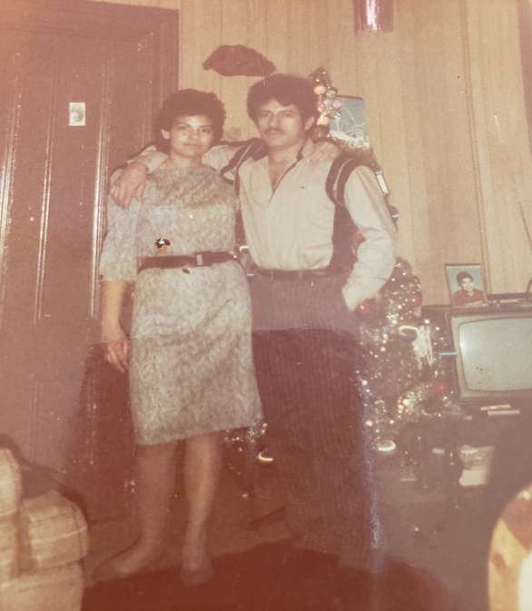
1981, First Christmas.

